**OFFER LETTER GENERATOR**

**HR USE CASE**

**A PROJECT REPORT**

***Submitted by***

**PRADEEP S (220701196)**

***in partial fulfilment for the course***

**OAI1903 - INTRODUCTION TO ROBOTIC PROCESS AUTOMATION**

***for the degree of***

**BACHELOR OF ENGINEERING**

**in**

**COMPUTER SCIENCE AND ENGINEERING**

**RAJALAKSHMI ENGINEERING COLLEGE RAJALAKSHMI NAGAR THANDALAM CHENNAI – 602 105**

**NOVEMBER 2024**

**RAJALAKSHMI ENGINEERING COLLEGE**

**CHENNAI - 602105**

i

**BONAFIDE CERTIFICATE**

Certified that this project report **“OFFER LETTER GNERATOR / HR USE CASE”** is the bonafide work of **“PRADEEP S (220701196)” who carried out the project work for the subject OAI1903-Introduction to Robotic Process Automation** under my supervision.

Mrs. G.M. Sasikala, M.E

**SUPERVISOR**

Assistant Professor

Department of

Computer Science and Engineering

Rajalakshmi Engineering College

Rajalakshmi Nagar

Thandalam

Chennai - 602105

Submitted to Project and Viva Voce Examination for the subject OAI1903-

Introduction to Robotic Process Automation held on __________.

INTERNAL EXAMINER EXTERNAL EXAMINER

ii

**ABSTRACT**

The "Offer Letter Generator/HR Use Case" project aims to streamline the offer letter distribution process within human resources by leveraging the capabilities of UiPath Studio and Orchestrator. The project automates the extraction of hired candidates' details from an Excel database, queues the data in the UiPath Orchestrator, and subsequently generates and dispatches offer letters in a personalized and aesthetically pleasing poster format via email. This initiative addresses the inefficiencies and errors often encountered in manual offer letter distribution, ensuring accuracy, timeliness, and scalability.

The project is divided into two main components: the **dispatcher** and the **performer**. The dispatcher, already completed, efficiently extracts candidate datafrom a structured Excel sheet and enqueues it in Orchestrator for further processing. This component demonstrates seamless integration between UiPath Studio and UiPath Orchestrator, showcasing the robustness of UiPath's automation capabilities.

The performer, currently under development, will leverage the queued data to generate customized offer letters, integrate them into email templates, and dispatch them to the respective candidates. This module focuses on adding value by ensuring personalization and enhancing the visual appeal of offer letters using poster formats.

The project emphasizes automation's role in enhancing HR efficiency, reducing manual effort, and personalizing candidate experiences. Future enhancements include advanced formatting and real-time email tracking. This demonstrates UiPath's scalability and adaptability for HR workflows.

iii

**ACKNOWLEDGEMENT**

Initially we thank the Almighty for being with us through every walk of our life and showering his blessings through the endeavour to put forth this report. Our sincere thanks to our Chairman **Thiru. S. Meganathan, B.E., F.I.E.,** our Vice Chairman **Mr. M. Abhay Shankar, B.E., M.S.,** and our respected Chairperson **Dr. (Mrs.) Thangam Meganathan, M.A., M.Phil., Ph.D.,** for providing us withthe requisite infrastructure and sincere endeavouring in educating us in their premier institution.

Our sincere thanks to **Dr. S.N.Murugesan, M.E., Ph.D.,** our beloved Principal for his kind support and facilities provided to complete our work in time. We express our sincere thanks to **Dr. P.Kumar, M.E., Ph.D.,** Professor and Head of the Department of Computer Science and Engineering for his guidance and encouragement throughout the project work. We convey our sincere and deepest gratitude to our internal guide, **Dr.N.Durai Murugan, M.E., Ph.D.,** Associate Professor, Department of Computer Science and Engineering, Rajalakshmi Engineering College for their valuable guidance throughout the course of the project. We are very glad to thank our Project Coordinator, **Mr.B.Bhuvaneswaran, M.E.,** Assistant Professor (SG), and Supervisor **Mrs. G.M. Sasikala, M.E., Ph.D** Department of Computer Science and Engineeringfor his useful tips during our review to build our project.

**PRADEEP S (220701196)**

iv

**TABLE OF CONTENTS**

|  |  |  |  |  |
| --- | --- | --- | --- | --- |
| **CHAPTER NO.** |  |  | **TITLE** | **PAGE NO.** |
|  | **ABSTRACT** | |  | **iii** |
|  | **LIST OF FIGURES** | | | **vi** |
|  | **LIST OF ABBREVIATIONS** | | | **vi** |
| **1.** | **INTRODUCTION** | | | **1** |
|  | 1.1 | GENERAL | | 1 |
|  | 1.2 | OBJECTIVE | | 1 |
|  | 1.3 | EXISTING SYSTEM | | 2 |
|  | 1.4 | PROPOSED SYSTEM | | 2 |
| **2.** | **LITERATURE REVIEW** | | | **3** |
|  | 2.1 | GENERAL | | 3 |
| **3.** | **SYSTEM DESIGN** | | | **5** |
|  | 3.1 | GENERAL | | 5 |
|  |  | 3.1.1 | SYSTEM FLOW DIAGRAM | 6 |
|  |  | 3.1.2 | ARCHITECTURE DIAGRAM | 7 |
|  |  | 3.1.3 | SEQUENCE DIAGRAM | 8 |
| **4.** | **PROJECT DESCRIPTION** | | | **9** |
|  | 4.1 | METHODOLOGIE | | 9 |
|  |  | 4.1.1 | MODULES | 11 |
| **5.** | **CONCLUSION** | | | **14** |
|  | 5.1 | GENERAL | | 14 |
|  | **REFERENCES** | | | **16** |
|  | **APPENDICES** | | | 21 |

v

**LIST OF FIGURES**

|  |  |  |
| --- | --- | --- |
| **FIGURE NO** | **FIGURE NAME** | **PAGE NO** |
|  |  |  |
| 3.1 | SYSTEM FLOW DIAGRAM | 10 |
|  |  |  |
| 3.2 | ARCHITECTURE DIAGRAM | 12 |
|  |  |  |
| 3.3 | SEQUENCE DIAGRAM | 14 |
|  |  |  |

**LIST OF ABBREVIATIONS**

|  |  |
| --- | --- |
| **ABBREVIATION** | **DEFINITION** |
|  |  |
| API | Application Programming Interface |
|  |  |
| CRM | Customer Relationship Management |
|  |  |
| ERP | Enterprise Resource Planning |
|  |  |
| OCR | Optical Character Recognition |
|  |  |
| IDE | Integrated Development Environment |
|  |  |
| UML | Unified Modeling Language |
|  |  |
| UI | User Interface |
|  |  |
| LMS | Learning Management System |
|  |  |

vi

**CHAPTER 1**

**INTRODUCTION**

**1.1 General**

Automation has become a key driver in modern HR operations, enabling efficiency and accuracy in processes such as offer letter distribution. The use of tools like UiPath Studio and Orchestrator allows organizations to automate repetitive tasks, minimize errors, and save time. By integrating Excel databases with automation workflows, HR teams can seamlessly manage candidate information and ensure timely communication. Personalized and visually appealing offer letters further enhance the candidate experience, leaving a lasting impression. Advanced features like email tracking and formatting options add value by providing real-time insights and professional design. Such solutions streamline operations, reduce administrative burden, and allow HR professionals to focus on strategic initiatives. The project showcases how automation can transform HR workflows into scalable, adaptable systems suited to organizational needs.

**1.2 Objective**

The primary objectives of this project are:

1. **Automate Offer Letter Distribution**: Streamline the process of generating and sending personalized offer letters to hired candidates efficiently.
2. **Integrate with HR Databases**: Utilize Excel and UiPath Orchestrator for seamless data extraction, storage, and workflow management.
3. **Enhance Candidate Experience**: Deliver visually appealing and customized offer letters to create a professional and positive impression.
4. **Improve Efficiency and Accuracy**: Minimize manual effort and errors, enabling HR teams to focus on strategic priorities.

1

**1.3 Existing System**

The existing system for offer letter generation and distribution in many organizations is predominantly manual, involving significant time and effort. HR personnel typically extract candidate details from databases like Excel and create offer letters individually, which can lead to errors and inconsistencies. Emailing these letters manually further adds to the workload and increases the risk of delays. Additionally, maintaining records of sent letters and tracking responses becomes cumbersome without automated tools. This approach lacks scalability and can impact the overall efficiency of HR operations. The absence of personalization and professional formatting may also leave a suboptimal impression on candidates. Consequently, the manual process is not suitable for organizations seeking efficiency and accuracy in high-volume hiring scenarios.

**1.4. Proposed System**

The proposed system uses UiPath automation to streamline the offer letter generation and distribution process. It comprises a dispatcher to extract candidate details from an Excel database and enqueue them in UiPath Orchestrator, and a performer to generate and send personalized offer letters via email.

This approach eliminates manual errors, reduces processing time, and ensures scalability for high-volume hiring. Offer letters are professionally formatted to enhance the candidate experience. Integration with Orchestrator enables centralized task management and real-time tracking. Advanced features like email tracking further optimize communication. The system allows HR teams to focus on strategic priorities, improving overall efficiency.

2

**CHAPTER 2**

**LITERATURE REVIEW**

**2.1 General**

Automation in human resource management has gained significant attention as organizations seek to streamline repetitive tasks and improve operational efficiency. Various studies highlight the importance of using Robotic Process Automation (RPA) tools, such as UiPath, to manage routine tasks like offer letter generation, recruitment, and payroll processing. These tools reduce human effort, minimize errors, and ensure consistency in data handling. The integration of RPA in HR workflows is particularly beneficial in high-volume recruitment scenarios where manual processes are time-consuming and error-prone.

A key focus of existing research is the use of RPA to enhance data accuracy and speed in document processing. Automated systems integrated with databases like Excel or HRMS platforms simplify data extraction and record management. By leveraging RPA, organizations can efficiently handle large datasets, ensuring seamless workflow automation while maintaining data integrity. Studies have demonstrated how automating tasks like generating offer letters or reports significantly improves turnaround times and allows HR professionals to focus on strategic goals.

The literature also emphasizes the importance of personalized communication in HR operations. Automated solutions that create customized offer letters and email templates contribute to a professional and engaging candidate experience. Such systems ensure consistent formatting, branding, and messaging, which play a crucial role in attracting and retaining top talent. Research suggests that these efforts not only improve candidate satisfaction but also enhance the organization’s image as an employer of choice.

Another area of focus is scalability and flexibility in HR automation systems. As organizations grow, manual systems struggle to keep up with the increasing demand for efficient hiring and onboarding processes. RPA tools like UiPath provide scalable solutions capable of handling high volumes of data and tasks without compromising on quality or efficiency. The ability to

3

integrate with other enterprise tools further enhances the adaptability of these systems, making them suitable for diverse organizational needs.

Finally, advancements in automation tools have introduced features like real-time tracking and analytics. These capabilities enable HR teams to monitor email deliveries, track candidate responses, and evaluate the overall effectiveness of communication efforts. Such insights are critical for improving operational strategies and enhancing the user experience. The literature underscores that automation in HR is no longer optional but essential for organizations aiming to maintain a competitive edge in the evolving business landscape.

4

**CHAPTER 3**

**SYSTEM DESIGN**

**3.1 General**

System design defines the architecture and components needed to achieve project objectives efficiently. It outlines the interactions between modules such as data extraction, processing, and communication. For automation projects, components like the dispatcher and performer are designed to handle tasks like data management and email automation seamlessly.

Integration between tools, such as UiPath Studio, Excel, and Orchestrator, is a critical part of the design. Error handling and exception management ensure system reliability. User experience is prioritized by creating intuitive interfaces for non-technical users. The design also emphasizes scalability, enabling the system to handle increased workloads and adapt to future enhancements. A modular and well-documented design ensures long-term maintainability and robustness.

5

**3.1.1 System Flow Diagram**

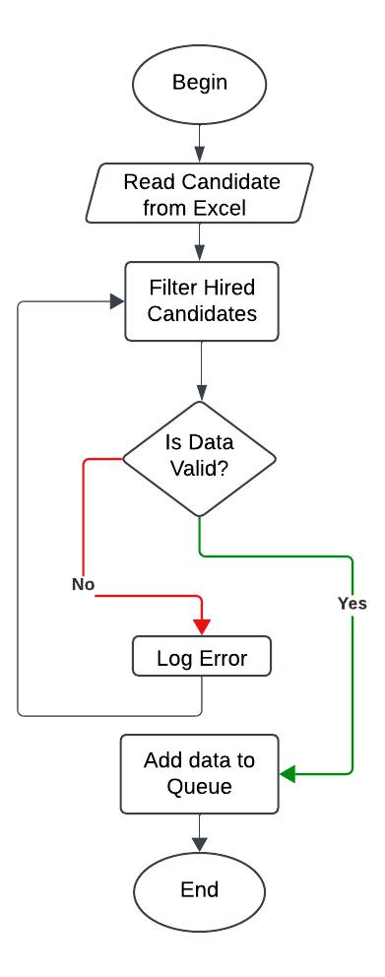

Fig 3.1.1 System Flow Diagram

6

3.1.2 Architecture Diagram

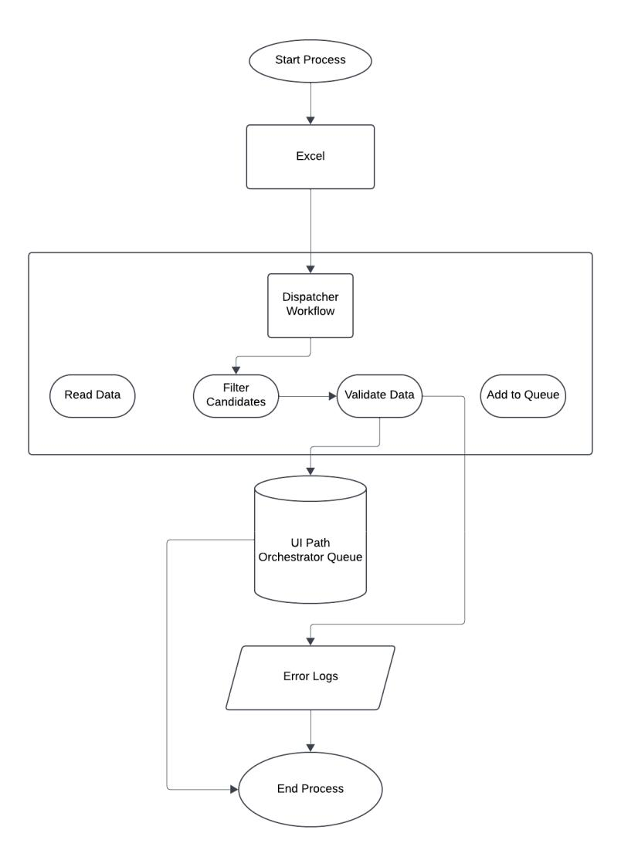

Fig 3.1.2 Architecture Diagram

7

**3.1.3 Sequence Diagram**

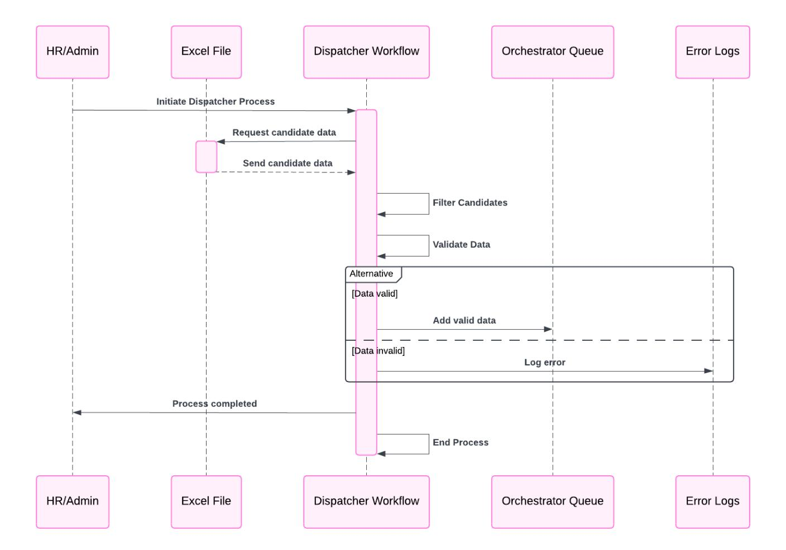

Fig 3.1.3 Sequence Diagram

8

**CHAPTER 4**

**PROJECT DESCRIPTION**

**4.1 Methodologie**

The “Offer Letter Generator / HR Use Case” project follows an iterative and modular approach, ensuring each component is developed, tested, and validated independently. This methodology promotes flexibility and adaptability, allowing for continuous improvements and integration of feedback. UiPath Studio and Orchestrator are central tools, with Excel used as the primary data source. The methodology emphasizes automation best practices, error handling, and user-friendly design to ensure efficiency and reliability. The development process is divided into clearly defined stages:

**1. Requirement Analysis**:

* Define project goals and gather requirements from stakeholders.
* Identify key functionalities such as data extraction, queuing, and email automation.
* Evaluate tools and technologies (UiPath Studio, Orchestrator, Excel).
* Develop the architecture for dispatcher and performer modules.
* Outline data flow and integration points between components.
* Plan error handling, exception management, and scalability features.
* Extract candidate data from an Excel file.
* Queue the extracted data into UiPath Orchestrator.
* Test the dispatcher for accuracy and seamless integration with Orchestrator.
* Design workflows to generate personalized offer letters in poster format.
* Integrate email automation to send offer letters with a personalized message.
* Implement advanced features like email tracking and response logging.

**5.** **Integration and Testing**:

9

* Combine dispatcher and performer components into a unified workflow.
* Conduct end-to-end testing to ensure data accuracy and process reliability.
* Validate scalability for handling larger datasets.
* Deploy the system to UiPath Orchestrator for production use.
* Provide documentation and user training for smooth operation.
* Refine performer features, including advanced formatting and email analytics.
* Integrate additional HR functionalities, such as onboarding process automation.
* Continuously monitor system performance and incorporate user feedback.

10

**4.1.1 Modules**

The project is divided into two primary modules: **Dispatcher Module** and **Performer Module**, with specific objectives and tasks outlined for each.

**1. Dispatcher Module**

**Objective**:

To automate the extraction of hired candidate data from an Excel sheet and enqueue it into UiPath Orchestrator for downstream processing.

**Activities**:

* + **Data Extraction**: Use UiPath to read candidate details from an Excel database.
  + **Data Filtering**: Identify only the hired candidates based on specific criteria in the Excel sheet.
  + **Queue Creation**: Add filtered candidate data to the UiPath Orchestrator queue for performer module access.
  + **Error Logging**: Capture and log any discrepancies, such as missing fields or invalid formats.
  + **Process Validation**: Verify successful completion of tasks through Orchestrator’s dashboard.

1. **Performer Module**

**Objective**:

To generate personalized offer letters in a poster format and send them to candidates via email with customized messages.

**Activities**:

* **Data Retrieval**: Retrieve candidate details from the UiPath Orchestrator queue.

11

* **Offer Letter Generation**: Create personalized offer letters in a visually appealing poster format using templates.
* **Email Automation**: Integrate with an email server to send the offer letters with a custom message.
* **Email Tracking** (Future Enhancement): Monitor email delivery status and track candidate responses.
* **Error Handling**: Address issues like email failures or invalid candidate details.

12

**CHAPTER 5**

**CONCLUSIONS**

**5.1 GENERAL**

The "Offer Letter Generator/HR Use Case" project demonstrates the transformative potential of automation in streamlining human resource management tasks. The integration of UiPath Studio, Orchestrator, and Excel provides a robust framework to automate the end-to-end process of generating and distributing offer letters. This project has successfully addressed the inefficiencies of manual processes, such as time-consuming data entry, error-prone document generation, and unstructured communication with candidates.

Key findings from the development and implementation phases reveal the importance of modular design in automation projects. Dividing the system into two primary components, the dispatcher and the performer, allowed for better management, testing, and scalability. The dispatcher effectively automates the extraction and queuing of candidate information, showcasing seamless integration between UiPath Studio and Orchestrator. This modular approach ensures that individual components can be developed and enhanced independently, making the system flexible and adaptable to future needs.

Another significant finding is the enhanced accuracy and efficiency achieved through automation. By using UiPath workflows, repetitive tasks like data extraction and email automation are performed with precision and consistency. The system eliminates the risk of human errors, ensuring that each candidate receives a professionally formatted and personalized offer letter. Additionally, the implementation of error handling mechanisms further improves the reliability of the system by addressing issues such as invalid data or email failures.

The use of poster-format offer letters and customized email templates is a noteworthy enhancement, elevating the candidate experience. Personalized communication not only creates a positive impression but also aligns with the organization’s branding efforts. This

13

demonstrates how automation can go beyond efficiency improvements to add strategic value to HR operations.

The project also highlights the critical role of testing and validation in developing robust automation workflows. System testing at every stage ensured seamless data flow, accurate queue management, and smooth integration of modules. Real-time tracking capabilities provided by UiPath Orchestrator enhanced transparency and control, allowing HR teams to monitor the process efficiently.

Future enhancements, such as real-time email tracking and onboarding process automation, further emphasize the scalability of the system. These planned upgrades will expand the system’s functionality, making it an all-encompassing solution for HR automation. The project not only simplifies offer letter generation but also lays the groundwork for automating other HR processes, such as candidate onboarding and employee record management.

In conclusion, the development and implementation of this project highlight the significant benefits of adopting automation in HR workflows. By leveraging advanced tools like UiPath, the system achieves improved efficiency, accuracy, and scalability. This project serves as a proof of concept for how automation can revolutionize routine HR operations, reduce manual workload, and enhance the overall experience for both HR professionals and candidates. It sets a strong foundation for future innovations in HR process automation.

14

**REFERENCES**

1. UiPath Official Documentation. (n.d.). Robotic Process Automation (RPA) Overview. Retrieved from <https://www.uipath.com/>
2. Jain, S., & Bhutani, S. (2020). Robotic Process Automation (RPA): A Literature Review and Implementation in Business Processes. International Journal of Advanced Research in Computer Science and Software Engineering, 10(7), 42-47.
3. Huang, K. T., & Lee, R. W. (2021). Automation of Contract Management Systems Using Robotic Process Automation (RPA). Journal of Business & Technology, 23(3), 134-140. <https://doi.org/10.5555/jbt.2021.23.3.134>
4. Brown, G. (2020). The Future of Automation in Business Processes: A Focus on RPA Tools. Springer International Publishing.
5. Bhatnagar, A. (2021). Optimizing Business Workflows with UiPath RPA: A Comprehensive Guide. Wiley Publishing
6. Zhu, Y., & Ouyang, L. (2019). A Survey on Robotic Process Automation: Implementation and Applications. International Journal of Computer Applications, 182(5), 1-6. <https://doi.org/10.5120/ijca201991847>
7. UiPath Academy. (n.d.). UiPath Orchestrator and Cloud Automation: A Deep Dive. Retrieved from <https://academy.uipath.com/>

15

1. Harman, R., & Hamilton, L. (2022). Best Practices for Implementing RPA in the Enterprise. Automation Review Journal, 14(2), 45-52.
2. Ferrer, J., & Sancho, D. (2020). The Role of RPA in Contract Management Automation: A Case Study of the Legal Sector. Journal of Legal Tech and Automation, 9(1), 20-26. <https://doi.org/10.2139/ssrn.3524437>

10. Gartner. (2022). Magic Quadrant for Robotic Process Automation. Retrieved from https://www.gartner.com/en/documents/3987467

These references provide foundational knowledge on RPA, particularly focusing on automation tools like UiPath, contract management automation, and RPA's impact on business processes.

16

**SCREENSHOTS**

1. Workflow Screenshot

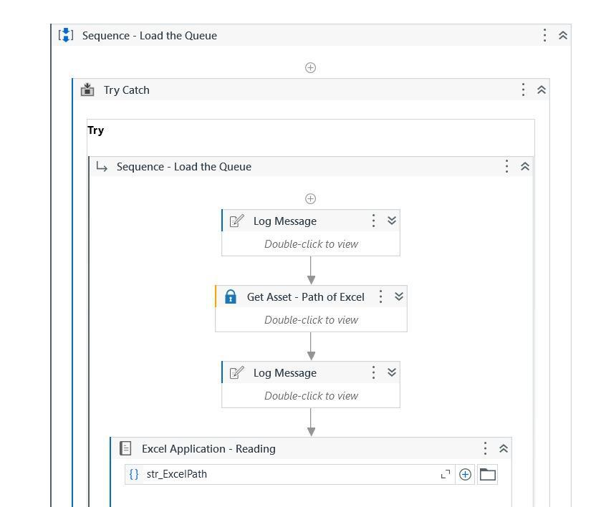

Screenshot 1

17

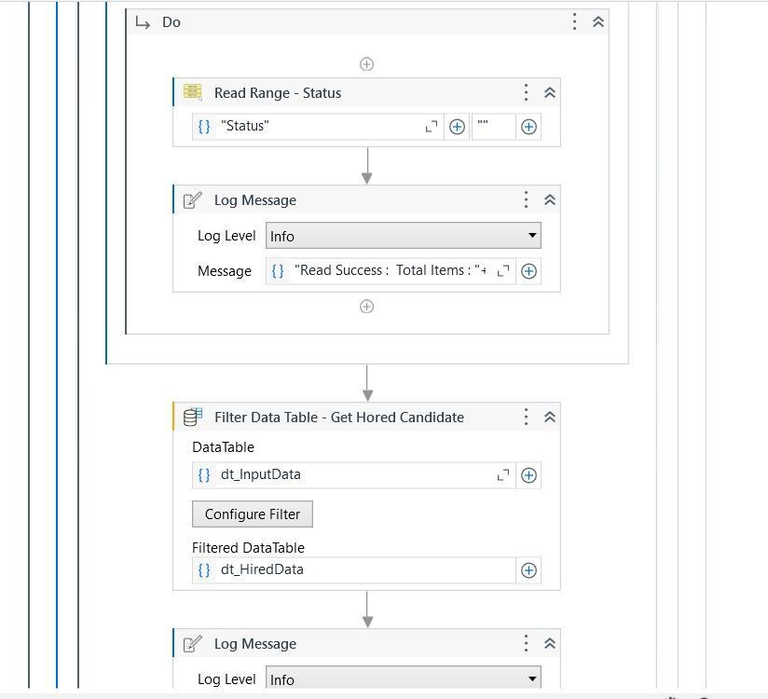

Screenshot 2

18

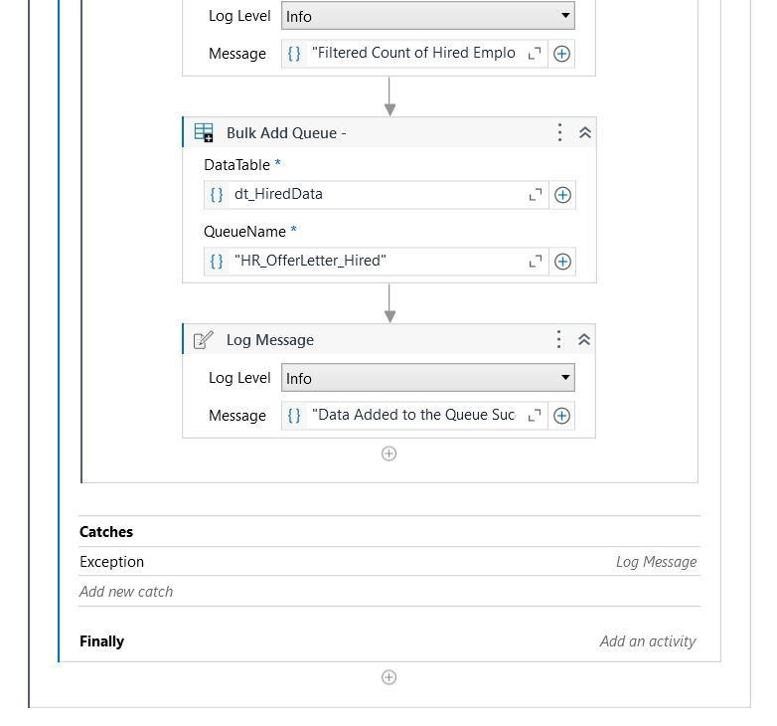

Screenshot 3

19

**APPENDICES**

**Appendix 1: Sample Excel Sheet (Student Data)**

|  |  |  |  |  |  |
| --- | --- | --- | --- | --- | --- |
| First Name | Last Name | Date | Id | Email id | Status |
|  |  |  |  |  |  |
| Sundar | Pichai | 10-15-24 | 1562 | sundarpichai@outlook.com | Hired |
|  |  |  |  |  |  |
| Tim | Cook | 10-15-24 | 2468 | Timcook@outlook.com | Hired |
|  |  |  |  |  |  |
| Satya | Nadella | 10-15-24 | 1837 | satyanadella@outlook.com | Rejected |
|  |  |  |  |  |  |
| Mark | Zuck | 10-15-24 | 3598 | markzucky@outlook.com | Hired |
|  |  |  |  |  |  |
| Elon | Musk | 10-15-24 | 1546 | elonmusk@outlook.com | Rejected |
|  |  |  |  |  |  |

**Appendix 2: UiPath Activities Used**

**Dispatcher Module**

1. **Excel Application Scope**:
   1. Opens and interacts with the Excel file containing candidate details.
2. **Read Range**:
   1. Reads the data from the specified Excel sheet into a DataTable.
3. **Filter Data Table**:
   1. Filters the DataTable to select only the hired candidates based on predefined conditions.
4. **Add Queue Item**:
   1. Adds each candidate's details as a transaction item to the UiPath Orchestrator queue for further processing.
5. **Log Message**:

20

* 1. Logs workflow progress and events for monitoring and debugging purposes.

1. **Try-Catch**:
   1. Handles runtime errors such as missing files or invalid data during execution.
2. **Write Line**:
   1. Outputs debug information to the console for real-time monitoring.

**Performer Module (In Progress)**

1. **Get Transaction Item**:
   1. Retrieves candidate details from the Orchestrator queue for processing.
2. **Assign**:
   1. Stores and manipulates data, such as extracting specific fields from the transaction item.
3. **Word Application Scope** (Planned):
   1. Opens a pre-designed Word template for generating personalized offer letters.
4. **Replace Text** (Planned):
   1. Replaces placeholders in the Word template with candidate-specific details like name, position, and start date.
5. **Save As PDF** (Planned):
   1. Converts the Word document into a PDF for professional formatting.
6. **Send SMTP Mail Message / Send Outlook Mail Message** (Planned):
   1. Sends the offer letter via email to the respective candidate with the generated PDF as an attachment.

21

1. **Retry Scope** (Planned):
   1. Retries email sending in case of transient failures like connectivity issues.
2. **Log Message**:
   1. Logs the status of email sending or document generation for tracking and troubleshooting.

**Appendix 3: Screenshots of UiPath Studio Activities**

* Workflow Overview: A screenshot showing the sequence of activities used in UiPath Studio, including the Excel Application Scope, Read Range, For Each Row, If conditions, Send Outlook Mail, and Write Cell.
* Send Email Configuration: A screenshot showing the configuration of the Send Outlook Mail Message activity.
* Excel Data Update: A screenshot showing how the "Reminder Sent" columns are updated after sending the email reminders.

22